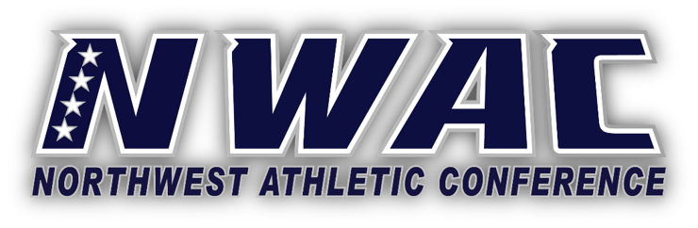

GUTHRIE FAMILY FUTURE LEADERSHIP AWARD
The Guthrie Family Future Leadership Award is given yearly to a deserving sophomore student athlete who exemplifies high quality leadership. The award is provided by Charles and Michelle Guthrie. One female and one male student-athlete will receive a$1,125.00 scholarship to be used at their next institution of higher education.
Criteria for Eligibility
- A second-year athletic participant at an NWAC member college.
- Will earn or has earned their AA degree at the conclusion of spring quarter.
- 3.50+ cumulative GPA.
- Involved in campus or community services.
- Demonstrated leadership skills while enrolled and competing at an NWAC member college.
- Winners need to be enrolled full-time in the fall at the four-year level.
Nomination Procedure
- College athletic director completes the Guthrie Family Future Leadership Award Nomination form for qualifying(s).
- Attach a copy of most recent unofficial NWAC college transcript.
- Provide one letter of recommendation from student athlete’s coach or athletic director.
- Email documents to Marco Azurdia at mazurdia@nwacsports.com by May 12.
Awards
- One female and male Guthrie Family Future Leaders Awards & Scholarship recipients will be selected by the Conference office.
- The winners will be notified by the NWAC office.
- Each recipient will be awarded a $1,125.00 scholarship to the four-year institution in which they will transfer and enroll.
- Winners are invited to attend the Hall of Fame Banquet to receive recognition of their achievements. Details will be provided to the award winners.

GUTHRIE FAMILY FUTURE LEADERSHIP AWARD
Name:______________________________________________
Email Address:______________________________________
NWAC College:______________________________________ Educational Emphasis:____
Sports Participated In (list gender):_______________________________________
Educational Goal:____________________________________________________________________
College(s) attended if other than current college attended:______________________________
Please include a copy of the student’s most recent NWAC college unofficial transcript and ONE letter of recommendation from student’s coach or athletic director.
Athletic Participation Indicate sport(s) and year(s)
College:______________ Sport:_____________ Year:____________
College:____________ Sport:_____________ Year:____________
Honors Received, Athletic, academic, leadership, etc.
College:_____________________________________________________________________________
____________________________________________________________________________________
Submitted by:_______________________________________________

